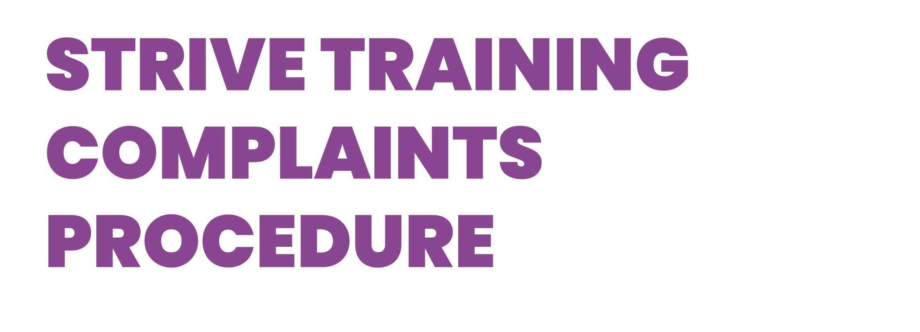

Purpose- This document outlines the procedure to be followed in the event of an informal/formal complaint.
Introduction

Strive Training recognises that all learners are of equal value and irrespective of gender/trans gender, age, race/ethnicity, disability/learning difficulty, sexual orientation, religion/belief and any other perceived difference. It is our policy that all learners can make a complaint about any issue which is of concern to them without the risk of disadvantage. It is also our policy that learners should be made aware of our complaints procedures.

All complaints received are carefully considered, this document explains the procedure for making a complaint. All complaints will be reviewed at regular intervals by the senior management and, should the complaint prove valid, action plans and targets for necessary improvements will be agreed. If appropriate, immediate action will be taken.

By letting us know when things go wrong you help us to put them right. Our complaints policy and procedures are set to help you take up any problems with us.

Therefore, we aim to ensure that:

- Making a complaint is as easy as possible
- We treat a complaint as a clear expression of dissatisfaction with our service which calls for an immediate response
- We deal with it promptly, politely and, when appropriate, confidentially
- We respond in the right way - for example, with an explanation, or an apology where we have got things wrong, or information on any action taken
- Learn from complaints, use them to improve our service, and review annually our complaints policy and procedures

If you have a complaint about our services, please follow the procedures set out below:

Step 1 | We recommend that you firstly discuss the problem with your tutor or a member of staff as he/she may be able to resolve the problem. If this does not resolve your issue you can make a formal complaint.
Step 2 | If you wish to make a formal complaint, please put this in writing via email to John Stapleton at Feedback@strivetraining.co.uk  Or in writing to:  John Stapleton  Strive Training  Japonica House, Ground Floor  Spring Villa Park, Spring Villa Rd  Edgware  HA8 7EB  - All formal complaints will be acknowledged in writing within 3 working days from the receipt of your complaint  - All formal complaints will be investigated, this may also include any further information required from yourself  - We will provide you with a response to the formal complaint within 15 working days
Step 3 | If you are not satisfied and wish to appeal against the decision to our response then please forward your formal complaint with evidence, within 5 working days from the date of the investigation outcome being communicated to you, in writing via email to Jonny Phillips at jphillips@strivetraining.co.uk  Or in writing to:  Jonny Phillips  Strive Training  Japonica House, Ground Floor  Spring Villa Park, Spring Villa Rd  Edgware  HA8 7EB  - Your complaint will be acknowledged within 3 working days of the receipt of the complaint  - The complaint will be reviewed by the senior management  - An outcome to your complaint will be sent within 10 working days and this decision will be final

Version | Description of changes | Date | Auth | Appr.
V16 | Review document | 01/08/23 | Kim Franks/John Stapleton | Jonny Phillips

