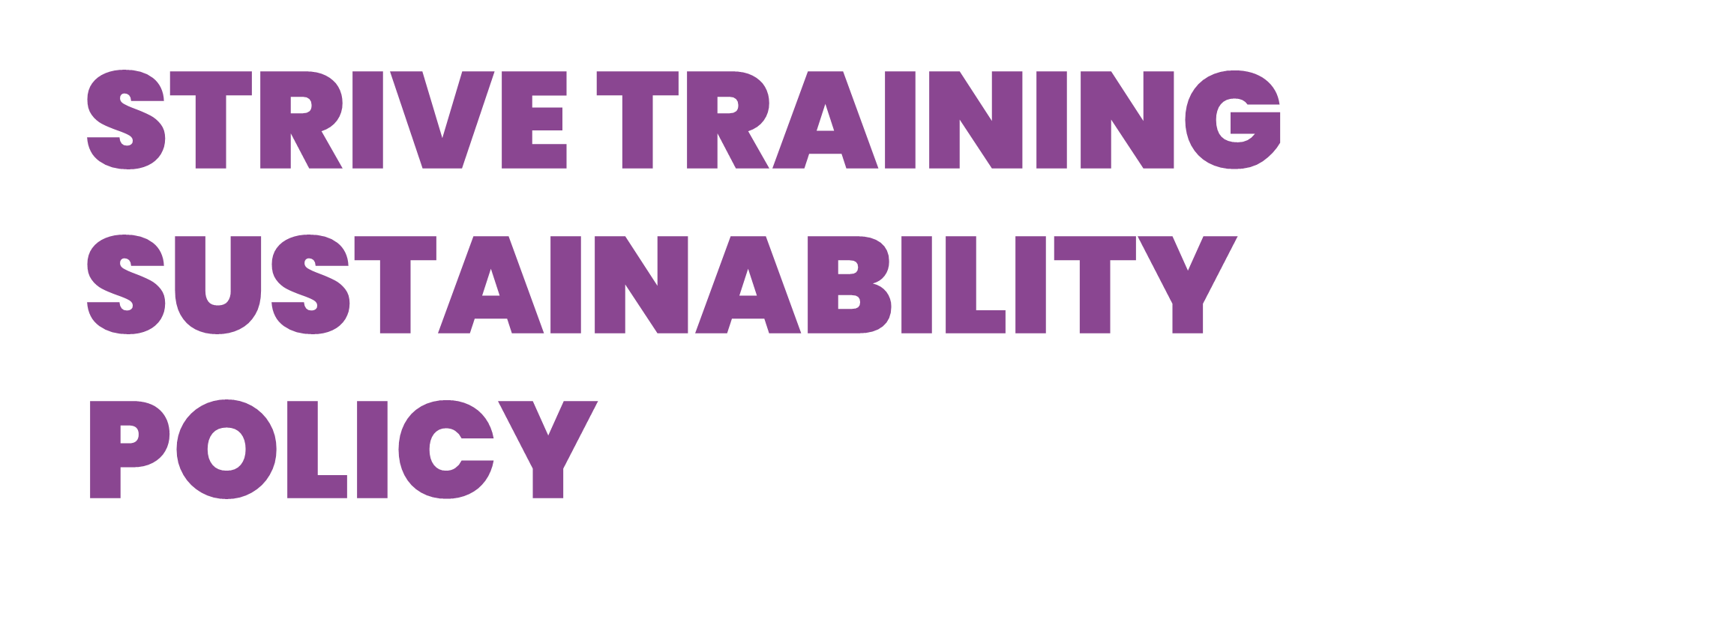

Purpose- This document outlines the commitment and objectives of Strive Training in ensuring its sustainable development.

Introduction
This Sustainability Policy applies to all Strive Training’s activities, products and services. All staff in Strive Training will follow the principles of this policy and supporting guidance to assist Strive Training to meet its sustainability objectives. A widely accepted definition of sustainable development is Development which meets the needs of the present without compromising the ability of future generations to meet their own needs (The Brundtland Commission, 1987). Strive Training recognises the importance of sustainable development for future generations and that its decisions and actions affect society and the economy, as well as the environment and natural resources at local, national and global levels. As a result, Strive Training is committed to:
- Maintaining compliance with all relevant UK, European and international legislative and regulatory requirements and agreements as a minimum standard.
- Reviewing all our activities and operations to identify, understand and evaluate all the direct and indirect environmental aspects and impacts, and prioritise action to address them.
- Supporting continuous improvement by establishing sustainability performance targets that are reviewed and externally reported annually.
- Ensuring that sustainable development is fully understood by staff and students and is enshrined within all aspects of planning and activities
- Fully committed to promoting sustainable development while delivering European Social Fund.
To implement this policy, Strive Training has undertaken a baseline review and has determined a set of key sustainability impacts and associated objectives:
- Energy and water: to reduce energy and water use and establish a utility monitoring and targeting system and to continue to explore the possibilities of less carbon intensive energy sources either through the purchase of renewable energy or through an increased use of onsite renewables. Furthermore, all computer systems are shut down when not in use to prevent energy wastage.
- Waste and natural resources: to prevent pollution by reducing emissions and discharges and to promote the zero-waste principle (rethink, reduce, reuse, recycle) to minimise the environmental impact of waste disposal and use of natural resources. Where possible, Strive Training aims to recycle any unused paper and ink cartridges. To dispose of waste using a registered waste collector and to observe and comply with the Waste Electrical and Electronic Equipment (WEEE) regulations and to ensure that WEEE is not mixed with general waste and is disposed of legally.
- Procurement: to develop and implement a sustainable procurement policy that integrates environmental and social issues with economic issues and that supports the use of products and services from contractors and suppliers who are in accordance with the Strive Training Sustainability policy.
- Education and Research for Sustainable Development: to further encourage the teaching of and research into sustainable development at Strive Training.
- Transport: to develop and implement a Strive Training wide green travel plan to minimise emissions arising from business travel, commuting and deliveries.
- Construction and Refurbishment: to incorporate the principles of sustainable development into any new build or refurbishment projects.
- Community Involvement: Build partnerships and take part in networks to share experience and knowledge of sustainability with the broader community and contribute to debate on sustainability issues.
- Health, Welfare and Safety: Promote the highest standards of health and safety for our staff, contractors and learners and provide a safe working environment for our employees, treating them with fairness, dignity and respect, as well as a safe learning environment for our learners.
- Training, awareness and communication: Increase the awareness and understanding of sustainable development amongst staff and learners through learning opportunities and training.
Strive Training’s Sustainability Policy is fully supported by the Strive Training senior management and administration team who have ultimate responsibility for the sustainability performance. All staff, learners, visitors and relevant external stakeholders share this responsibility.
Implementation Plan:
To continue to manage our environmental aspects, impacts and risks we have committed to implement the following actions:
Waste Reduction
Strive Training will:
- Implement sustainable resource management practices based on ‘reduce, reuse, recycle’ principles;
- Re-use and recycle materials wherever practicable;
- Reduce the amount of waste being disposed of in landfill sites, by segregating different types of waste;
- Measure and monitor waste;
- Prevent pollution;
- Comply with legislation and meet the requirements of waste regulators. Dispose of waste using a registered waste collector and comply with all WEEE regulations.

Water
Strive Training will:
- Make efficient and responsible use of water;
- Managing and reducing water consumption where possible.

Carbon Management
Strive Training will:
- Ensure the uptake of low-carbon technology in buildings and equipment;
- Preventing pollution by managing and reducing emissions to air and discharges to water.

Transport
Strive Training will:
- Implement sustainable transport practices across all activities;
- Encourage the use of public transport, walking, cycling and vehicle sharing, where appropriate;
- Encouraging reduced dependency on single occupancy car travel to and from Strive Training and between sites.

Ethical and Sustainable Procurement
Strive Training will:
- Promote the use of sustainable resources whenever practicable;
- Promote lifecycle thinking in the procurement of goods and services;
- Promote the development of central purchasing strategies to ensure efficient and sustainable purchasing practices.

Education for Sustainable Development
Strive Training will:
- Develop links with local and national groups which encourage education for sustainable development
- Endeavour to embed education for sustainable development into all curriculum areas;
- Promote learning that includes sustainability and citizenship.

Social Responsibility
Strive Training takes social responsibilities very seriously and sees this as an essential part of our business. As a well-renowned and reputable training provider and employer, we have a major role to play in the social and economic welfare of the Greater London area and nationwide, and an ethical responsibility to our planet.
As part of the Strive experience, learners are encouraged to consider their own social responsibility through our courses which embed British Values. We encourage our learners to be healthy, stay safe, enjoy and achieve, and make a positive contribution and economic well-being.
Strive recognises the importance in maximising the physical, mental and social wellbeing of all learners and promoting a safe and healthy environment in which teaching and learning can take place:
- To promote learner health and wellbeing through Strive Training policies, support services and information networks and by liaising appropriately with external agencies.
- To prevent, as far as is practicable, those circumstances detrimental to physical and mental health and wellbeing.
- To reinforce the role of Strive Training in contributing to local and national strategies.
Our curriculum planning also takes into account social responsibility, specifically our Lifestyle Matters accredited qualification enables learners to achieve positive mental wellbeing.
Sustainability Action plan
Strive Training is committed to leading change in environmental sustainability. The following table sets out the strategic aims and objectives for sustainability.
Strive’s carbon reduction plan can also be accessed via our website: https://strivetraining.co.uk/policies/
Rationale:

Educating for success:
- Educate and inspire our students to become socially responsible and environmentally aware members of our future society.
- Support academic colleagues and multi-disciplinary teaching to incorporate sustainable development into teaching and research.
Growth Capacity and influence:
- Innovation that promotes development
- Improve our bottom line through resource efficiency.
Raising standards and aspirations:
- Strengthen our standards and improve our performance in environmental sustainability
- To embed sustainability as business as usual linking the 3 core aspects of sustainability (social, environmental and economic) through Strive’s policy and strategy.

Aims | Objectives | Actions | Responsibilities
Aspire to create a learning environment where students are provided with the opportunity to become informed on the applicability of sustainability to their area of study | To embed elements of sustainability across the curriculum using the teaching, learning and curriculum initiatives. To provide opportunities for learners to develop skills to respond to global sustainability challenges.  To provide appropriate training to permanent and freelance delivery staff with professional development opportunities in educating for sustainable development | Use of alternative technology and resources  Conduct a review of all taught units, develop training initiatives, generate open access online resources and implement monitoring procedures. | Senior Management Team  All permanent and freelance staff
Encourage knowledge transfer amongst our employed and freelance staff and learners that can contribute to a meaningful and positive approach to addressing some of the challenges of sustainable development and Social Responsibility | To communicate and promote our environmental sustainability activities and achievements to the learners. | Support all staff with opportunities to discuss best practise and alternative methods/resources | Senior Management Team
To manage our centres in an efficient and low risk way reducing our impact through ongoing monitoring of our operational processes, systems and outputs. | Waste - To ensure that, in accordance with WEEE legislation, waste will be managed in a sustainable manner following the waste hierarchy  Carbon - To reduce the institution's carbon footprint, focusing on the reduction in use of gas and electricity from the national grid.  Water - To reduce water consumption from the centres and head office operations.  Construction and Refurbishment - To reduce the impact of construction  refurbishment and maintenance of the Strive Training centres  Sustainable Travel - To reduce the use of fossil fuels for personal and business travel to decrease the carbon impact of these as part of the transport management strategy.  Emissions to Air & Discharges to Water - To reduce risk of pollution.  Sustainable Procurement - To reduce the demand for non-sustainable goods and services.  Noise Pollution - To reduce complaints and nuisance. | Deliver operational objectives and targets in the following areas:  - Waste Management  - Carbon Management  - Water Management  - Construction and Refurbishment  - Sustainable Travel  - Emissions to Air & Discharges to Water  - Sustainable Procurement | Centre Supervisors  Senior Management Team

Policy | Version | Updated | Updated by | Agreed by | Approved by
Sustainability Policy | V21 | 1 August 2023 | Kim Franks | John Stapleton | Jonny Phillips

Addendum
Addendum Effective From: | 7th October 2019
Between (Parties ) | Strive Training (London) Limited and GLA
Addendum Terms/ Modification | Sustainable Policy V21 applies to GLA AEB/ESF Contract

