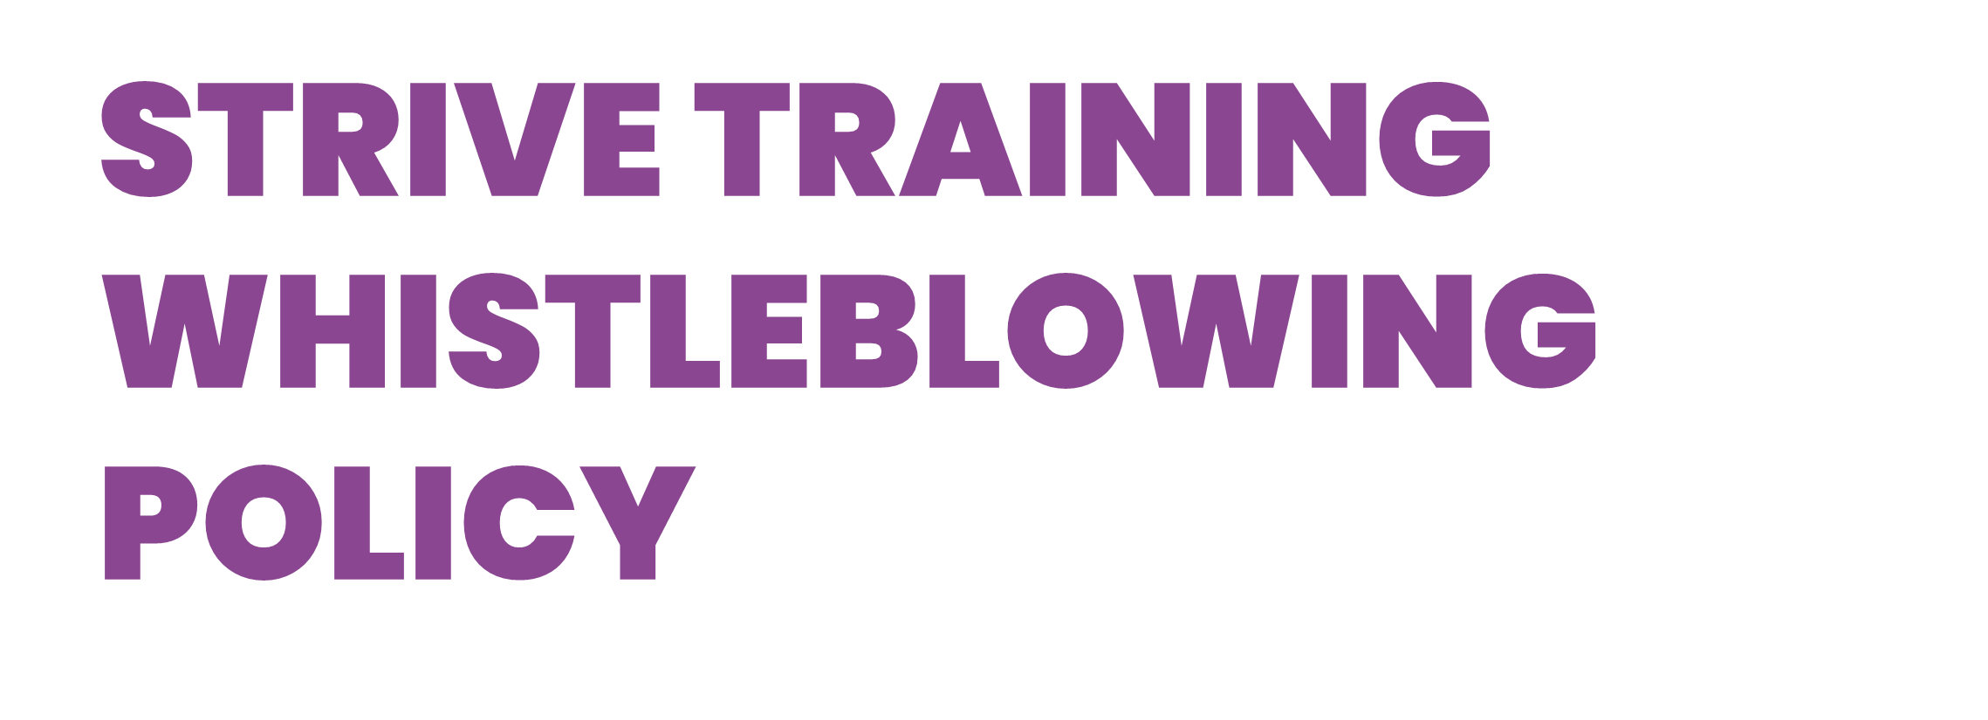

Introduction

Strive Training is committed to the highest possible standards of openness, honesty and accountability. Therefore, Strive Training Directors and Senior Managers encourage employees to reveal truthful and factual information of any actions that are taken by Strive Training staff that are potentially illegal, corrupt, improper, unsafe or unethical which relates to malpractice.

This Policy applies to all permanent, temporary, full-time, part-time, and casual staff employed by Strive Training, as well as all Strive Training contractors and volunteers.
Definition

Whistleblowing has been defined by Public Concern at Work Guidelines 1997 as:

“…the disclosure by an employee or professional of confidential information which relates to some danger, fraud or other illegal or unethical conduct connected with the work place, be it of the employee or his/her fellow employees”.

Serious concerns could include, but are not limited to, the following list of actions:
- Conduct which has failed, or is likely to fail, to comply with a legal obligation;
- Disclosure related to miscarriages of justice;
- Actions which endanger the health or safety of any individual, including risks to students or the public, or other staff members;
- Damage to the environment;
- Theft or misuse of Company property or assets;
- The unauthorised use of public funds;
- Possible fraud or corruption;
- Serious departure from professional standards;
- Sexual or physical abuse of students or staff

Safeguarding

Strive Training recognises that the decision to report a concern can be difficult because of the fear of reprisal from those responsible for the malpractice. Strive Training will take action to protect the staff member who raises a concern in good faith. Strive Training will treat whistle blowers as witnesses and not complainants. It will not tolerate any resulting harassment or victimization (including informal or indirect pressures) and will treat this as a serious disciplinary offence which will be dealt with under the appropriate procedures.

Any investigation into an allegation of malpractice will not influence or be influenced by any disciplinary or redundancy procedures which already affect you.
False Allegation

If you make an allegation in good faith but it is not confirmed by the investigation, no reprisals will be taken against you. If however, you make malicious or vexatious allegations, disciplinary action may be taken against you.
Raising a concern anonymously

This policy encourages you to put your name to your allegation. Concerns expressed anonymously are much less powerful but they will be considered at the discretion of Strive Training management against the following criteria:
- The seriousness of the issue raised;
- The likelihood of confirming the allegation from attributable sources;
- Strive Training’s best interests;
- The protection of Strive Training’s assets.

If you request for your identity not to be disclosed, we will honor your request unless we are required by law to reveal your identity. Your name may also need to be revealed when your evidence is required to be presented. You should also be mindful that if you do choose to raise a concern anonymously, it will be more difficult for the matter to be investigated and for you to be provided with feedback.
How to raise a concern

Concerns should be expressed in writing directly to your line manager. If the concern involves your line manager then the concern should be raised in writing to the next senior manager. If you do not feel comfortable with raising the concern with a member of the management team, you may raise the concern with the HR Manager and stipulate why you feel unable to raise the concern in the usual way.

It is expected that the person receiving the allegation will be the investigator. However it is at the discretion of the investigator to delegate the investigation to another person if deemed to be appropriate. You have the right to ask for the matter to be treated confidentially.

You should set out the background and history of the concern; giving names, dates and places where possible, and explaining the reason for your concerns. If you feel unable to put your concern in writing you can still raise the concern verbally.
Steps for the investigator to follow

The investigator should:
- Interview the member of staff privately within 7 days of the concern being raised, or immediately if there is a threat of loss of life or serious injury;
- Obtain as much information as possible about the alleged malpractice from the person raising the concern;
- Discuss with the individual what relevant steps should be taken and keep them informed of progress and actions throughout the process;
- The most senior member of staff dealing with the investigation will keep records of the matter and monitor the progress until the case is closed.

Response to a concern

Where appropriate, the concerns raised may be:
- Investigated by managers, internal audit, or through the disciplinary process;
- Investigated by other procedures; such as safeguarding vulnerable adults;
- Investigated under procedures designed to deal with allegations made against professionals;
- Referred to the Police;
- Referred to the external auditor or other external investigation;
- The subject of an inquiry;
- Investigated under other forms of prosecution and inspection such as the protection of public health and safety; or
- Referred to an independent investigator.

All Safeguarding concerns raised through this process are managed in accordance with both London Safeguarding Children Board (LSCB) procedures and DfE guidance.

Taking the matter further

If no action is taken and you are not satisfied with the way the concern has been dealt with, you can raise your concerns with third party, independent organisations, as listed below:
- A Solicitor
- The Police – for concerns of criminal behaviour
- Health and Safety Executive
- Local Citizens Advice Bureau
- Public Concern at Work – an independent charity that provides free advice for persons who wish to express concern about fraud and other serious malpractice. Telephone 0207 404 6609 and website www.pcaw.co.uk.

Non-whistleblowing issues

Whistleblowing is the raising of a concern where others, or the organisation itself, are at risk. However, should you wish to raise an issue that concerns yourself, you may refer to Strive Training’s grievance procedure in the Employee Handbook.

Version | Description of changes | Date | Auth | Appr.
V13 | Review document | 01/08/23 | Kim Franks | Jonny Phillips

